Bail Conditions
Name ________________________________ Date _______________
Next Court Date: ______________________ Location: ______________________
Bail conditions = the rules the Court has given you
keep the rules and finish your plan  if you break the rules, you are in
trouble with the court and may have to pay

___$__________________________________________
You must live at  If you move, you have to let  know within 24 hours | You are NOT to
You can go OUT with WHEN
You must be HOME



You can take medicine prescribed by your doctor or pharmacy. | You are NOT allowed to possess or take any drugs that  have not been prescribed.
      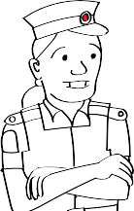  Come to the door if  the Police knock on the door. | 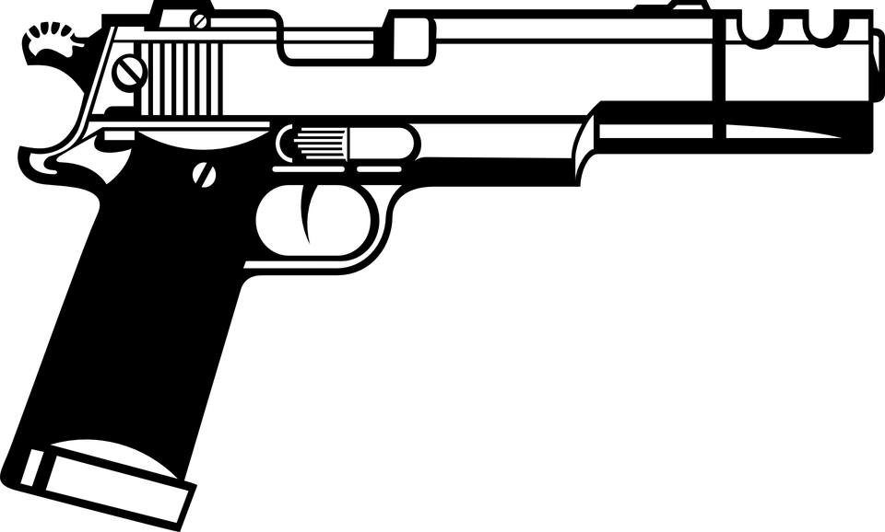  No Weapons

Your Lawyer _________________________________________________ Phone: ___________________
Your Bail Supervisor __________________________________________ Phone: ___________________
*Adapted from Talking Trouble Bail Conditions https://www.talkingtroublenz.org

