Bail Conditions
Name ________________________________ Date ________________________
Next Court Date: ______________________ Location: ______________________
Bail conditions = the rules the Court has given you
keep the rules and finish your plan  if you break the rules, you are in
trouble with the court and may have to pay

___$__________________________________________
You MUST live at  If you move, you have to let  know within 24 hours | You are NOT to
You CANNOT go to:
You CANNOT be with or call or contact:
You MUST be home:
You WILL attend programs directed by your supervision officer.
You are NOT allowed to possess or take any drugs that  have not been prescribed by a doctor | 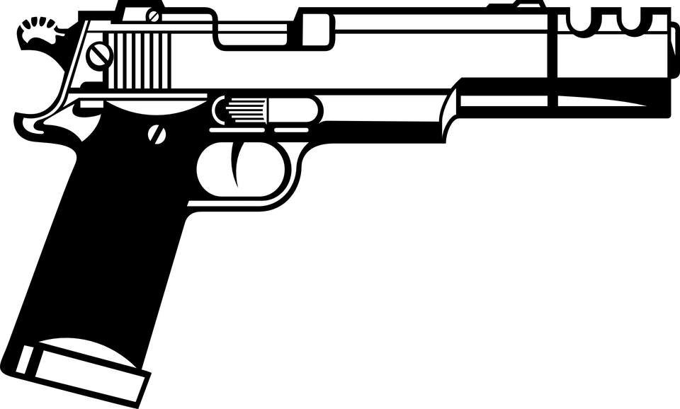  You can’t have weapons  



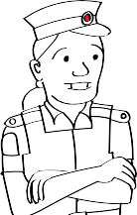
Come to the door if the Police knock on the door

Your Lawyer/Bail Supervisor________________________________________ Phone: ___________________
*Adapted from Talking Trouble Bail Conditions https://www.talkingtroublenz.org

